Readings & Assignments: Week 3
Week 3 Readings
Complete the following readings early in the week:
- Week 3 online lectures
- From 3ds Max Help file, read the following topics:
  - Animation Concepts and Methods
  - Time Configurations
  - Reference Coordinate Systems
  - Set Key Animation Mode
  - Auto Key Animation Mode
  - Track View
  - Dope Sheet
  - Track View Workspace
  - Using Dummy Objects or Dummy Helpers
  - Animation Preferences
While reading, make note of pertinent and important facts. You will be required to reference your readings in discussions and apply them in this week’s assignments.
Week 3 Assignments Overview
Assignment Summary: Week 3 | Due Date
Assignment 1: Discussion Questions | Saturday, March 6, 2010
Assignment 2: Domino Animation | Sunday, March 7, 2010
Assignment 3: Rubber Ball Bounce | Monday, March 8, 2010
Assignment 4: Final Project | Monday, March 8, 2010
Using the navigation on the left, please proceed to the next page.

Week 3 Overview
In the last two weeks, you learned about UVW mapping coordinates and how they are used in three-dimensional (3D) objects.
Creating proper UVW mapping coordinates and adding material and textures to a scene make objects look real and interesting. However, these objects have to be animated to produce lifelike 3D movies and video games.
This week, you will be introduced to the methods of animation and the concept of adding motion to 3D objects.
3ds Max provides many tools and options, which when combined with proper animation techniques can animate any 3D model with realistic motion. This week, you will learn how to set up object files for animation and prepare your models for animation.
You will also learn how to apply keyframes and then adjust those keyframes to give your animation a polished look.
Let's begin by understanding the basic concepts of animations.

Learning Outcomes
- Create complex material and UVW mapping solutions.
- Demonstrate the ability to apply basic material to 3D models.
- Exhibit the ability to apply animation techniques to 3D models.

Animation Concepts and Options
Before starting to animate your 3D models, you first need to identify if the models created in 3ds Max have the proper settings for animation.
The settings are determined by two parameters:
- Time configuration
- Reference coordinate system

Time Configuration
Standards define how an animation should be broadcast and sent as output to various media.
The U.S. standards for broadcasting any form of digital video, for example, animation, are defined by the National Television Standards Committee (NTSC). In European countries, there is a standard known as Phase Alternating Line (PAL) for digital video broadcast. The broadcasting standards require different settings, for which you need to configure your animation files.
Setting 3ds Max files with the proper time configuration, frame rate (the rate at which each frame will be played), and aspect ratio (the ratio of the width to the height of a frame) ensures that when you are ready to render the animation, it fits the output type.
The time configuration dialog box provides options for different animation settings. These options include the frame rate, time display, and animation length.
The time configuration settings also define how many frames of animation will be viewed per second. For example, in the U.S., it is a norm to configure your animation such that when it is sent as output to a video home system (VHS) tape or a digital video disc (DVD), 29.97 frames—more commonly known as 30 frames—per second are played.

Reference Coordinate System
Each object has its own local center and a coordinate system as defined by the location and orientation of the object's pivot point. The local center and the coordinate system of an object together define its object space.
The reference coordinate system enables you to specify the coordinate system used to transform—that is, move, scale, and rotate—an object.
Each coordinate system in the reference coordinate system drop-down list affects how an object is transformed in the X, Y, and Z coordinates. By default, the coordinate system is set to the View option, and how the object is manipulated in the XYZ direction depends on whether the viewport that is active is orthographic or perspective.
Coordinate systems, including reference coordinate systems, are based on each transform. Therefore, you need to first select the transform—move, scale, or rotate—and then select the coordinate system. For example, if you choose to move an object using the local coordinate system (a coordinate system that relates specifically to the selected object), when you go to the scale or rotate transform, the default View Coordinate System is used.
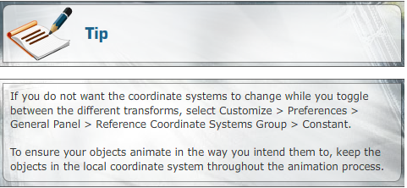
When your scenes are set up for animation, you can start putting the 3D objects in motion. To ensure that your objects transform at specific times, you need to define states for the 3D objects by adding keys.
In the next lecture, you will learn what these keys are and how they are used to specify time.

Keyframing: Auto and Set Keys
Keys are used to mark an object's state on individual frames. Keys enable your computer to register where an object was placed in its initial state, where it will be in its final state, and how it looks in the frames produced between the initial and final states. In other words, where you place your keys in the timeline, the space between those keys, and how individual keys transit from one to another determine the outcome of an animation.
To position your objects for animation in 3ds Max, you can use either the Set Key or Auto Key animation mode. The main difference between the two methods of adding keys is that the Auto Key option automatically adds a key when an object is transformed. The Set Key option enables you to set the key once you are ready to establish the state of an object.
In the Set Key animation mode, the large icon of a key enables you to start setting keys on the timeline; Auto Key does not require you to use the Set Key icon.
Before setting keys, you should ensure that what you want to be keyed on an object is set. You can do this by selecting the Set Key Filters option. Note that when the Auto Key button is clicked, it will automatically key anything that Set Key Filters option is set to key. Therefore, if you are manipulating a scene with Auto Key on, those changes will be keyed. Make sure that Auto Key is on only when you want to automatically add keys to the timeline.
You have now learned how to set a scene and objects using keys in 3ds Max. However, when you create complex animations, you need more assistance to successfully link and coordinate your 3D objects and the overall scene.
In the next lecture, you will learn about Dummy objects that help to create complex animations in 3ds Max.
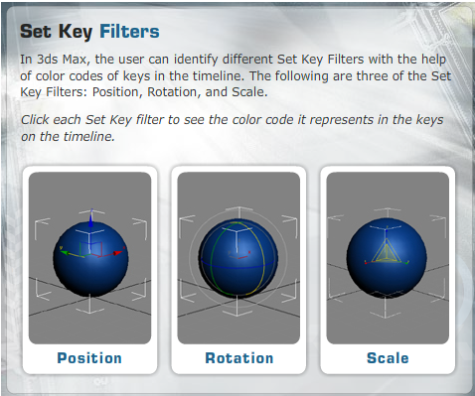
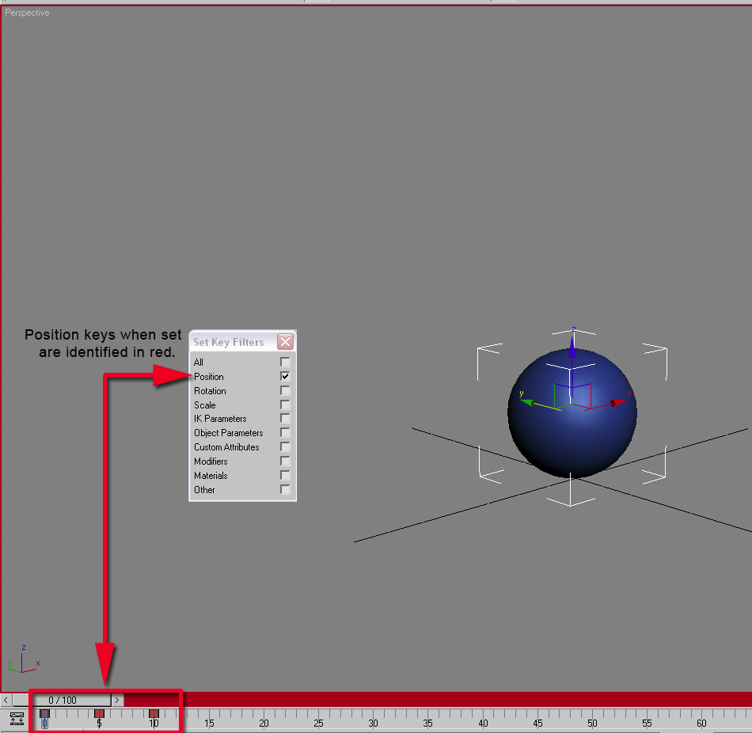
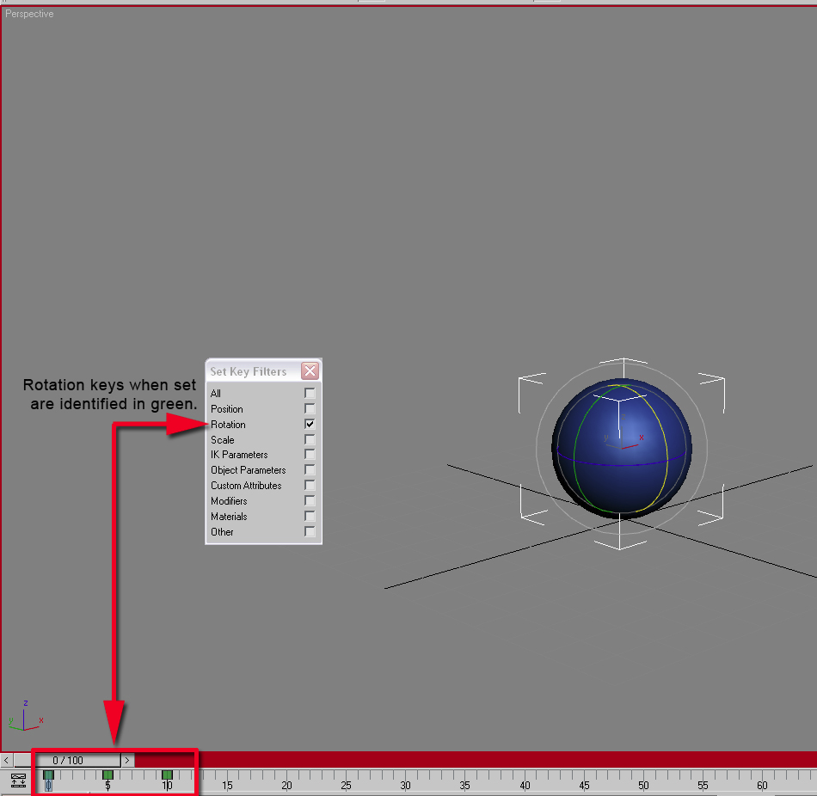
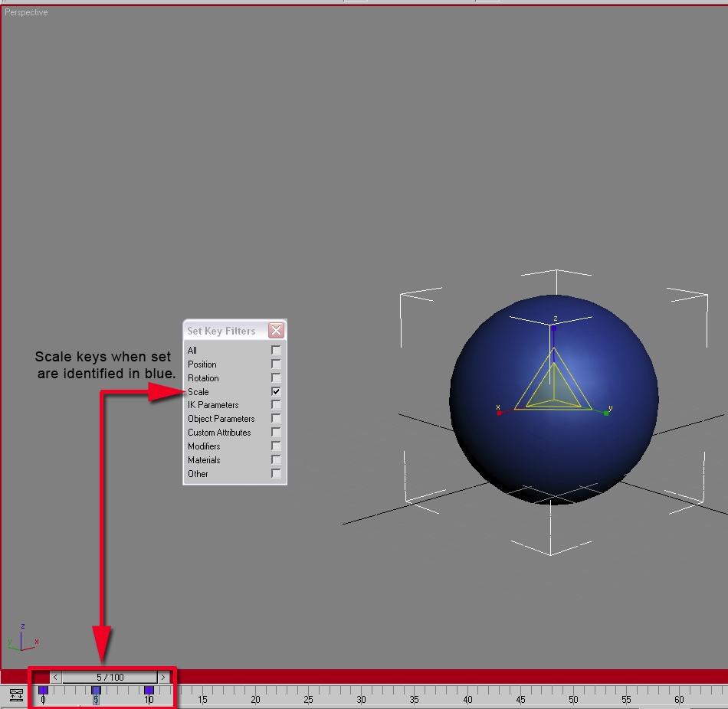

Dummy Objects
The complexity involved in animation and the manipulation of objects during animation is so high that 3ds Max provides helpers to assist in the animation process. One of the most common helpers is the Dummy object, which becomes invisible only in the final render state.
The Dummy object is linked to an object in a scene to form a relationship between the object and the scene. The Dummy object cannot be rendered and has no parameter to be modified; it does, however, have its own pivot point, the axis around which an object rotates or from which the object scales. A user can have multiple pivot points to animate a scene and objects together. This pivot point is adjustable and determines how an object transforms. A Dummy object, when linked to a 3D object, works with two separate pivots to position objects, rotate objects, and scale objects from. Both these positions effectively help to first set an object's position and rotation with one pivot point location and then squash or scale the object based on the other pivot point location.
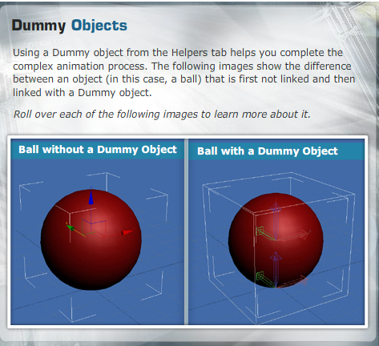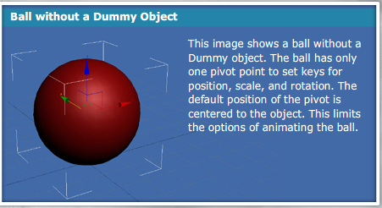
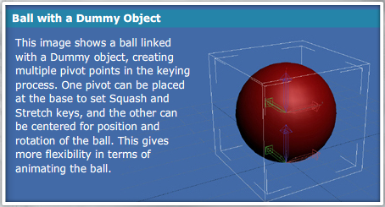
After an animation is complete or the keys are set, the animation is adjusted to refine the final look. 3ds Max provides you with options for adjusting the key transition and timing configuration between each key. This is done using Graph Editors. In the next lecture, you will learn about Graph Editors in detail.

Graph Editors
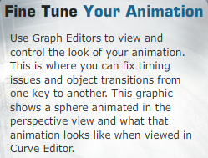
How an object moves from one key to another can make the difference between an animation that resembles real motion and one that actually mimics real motion.
Using Graph Editors and Track View to analyze the keys and their function curve—the form in which Curve Editor displays an object's motion from one key to another—aids in modifying the animation and bringing finesse to the final product. Track View provides a hierarchical view of your animation and scene and displays the relationship between models.

Graph Editors > Track View - Curve Editor
As mentioned earlier, depending on what has been keyed, different colors get applied in Key Filters. The different colors become even more important in Curve Editor when adjusting the function curves. Each key can be adjusted to know how it is interpolated between the keys of an animation. 3ds Max has a list of key tangents that perform different functions as the animation goes in and out of the key. Adjusting the tangent type between keyframes enables you to change the motion of objects in the animation. This is how animators get the final results after establishing keys in the timeline.
Making sure you adjust the function curves to manipulate the values of the keys and the key tangents will help you refine an animation to get the desired result. The timing of an animation is another critical aspect of making sure the
computer-generated animation is as close to real motion as possible. For this, 3ds Max provides a tool called Dope Sheet.

Graph Editors > Track View - Dope Sheet
You will learn about this tool in more detail in the next section.
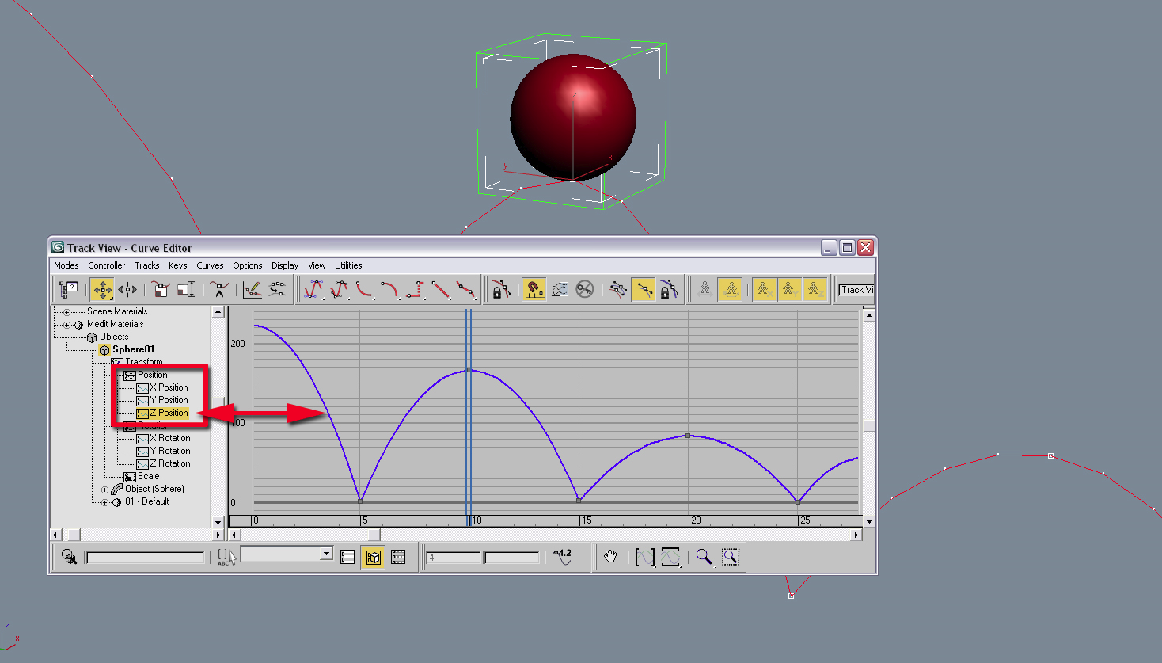

Using the same color coding as the timeline and Curve Editor, Dope Sheet displays all the keys that have been set for an object. You can use Dope Sheet to add keys to and delete keys from a scene and also change the time of an animation by moving, sliding, and scaling the keys. By doing this, you can change the time it takes to transit from one key to another, eventually changing the look and feel of an animation.
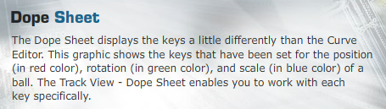
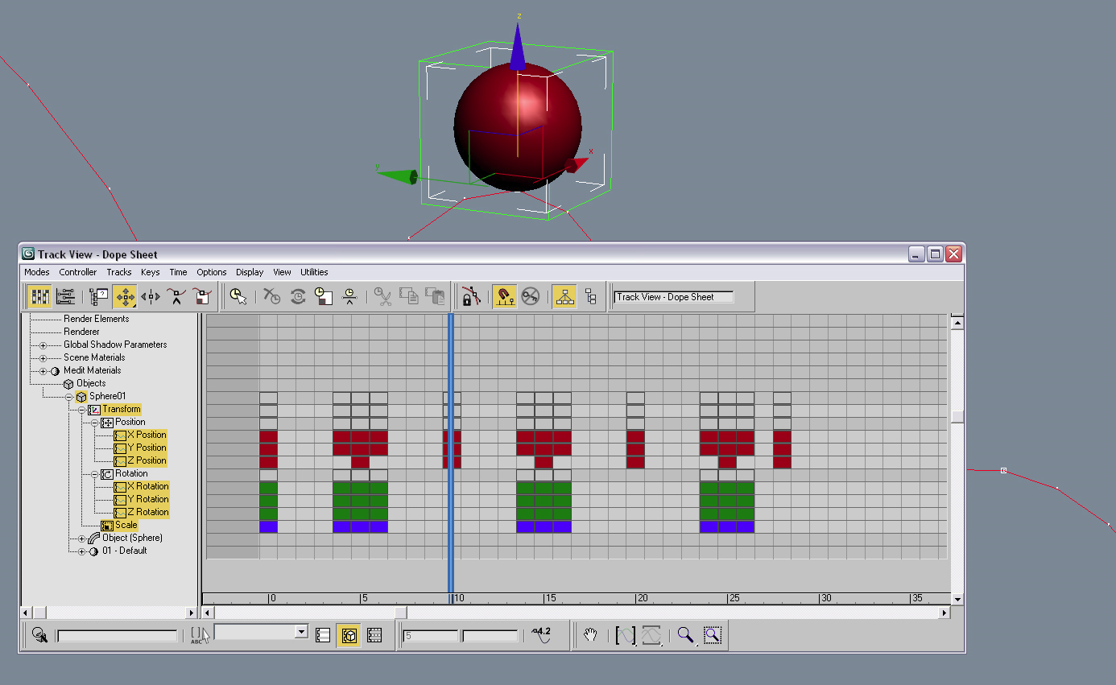
When you enable the keys in Dope Sheet to be edited, you have control over the keys in your animation. Having the ability to manipulate the keys in various ways helps you achieve the desired look for any object being animated.
It is important for an animator to understand the basic settings and controls to manipulate the motion of objects. You cannot make path-breaking animations unless you know the basics.
This brings us to the end of this week's lecture. Let's summarize the key learning from the week.

Summary
In Week 3, you learned how animation works for objects and models in 3ds Max. You learned that the look of an object in a scene is important but that animating the object adds a level of interest that makes today's 3D animated movies and next-generation video games popular products.
Next, you learned that you need to use the reference coordinate system and the adjust pivot points of objects to set up your scene for animation. This also enables you to have more control on how you set keys at a particular place in time.
You learned that after establishing the main keys, you can use the Set Key or Auto Key method and analyze and tweak the animation-function curves to give finishing touches to your animation before you do a final render.
Next week, you will look at more concepts, tools, and techniques that help you create complex animations. You will also learn about various functions provided by 3ds Max to assist you in the animation process.

Assignment 1: Discussion Questions
By Saturday, March 6, 2010, respond to the discussion questions assigned to you by the facilitator. Submit your responses to the appropriate Discussion Area. Start reviewing and responding to your peers’ posts as early in the week as possible. You can ask a question, post a comment, or add a point to expand the discussion. Be honest, clear, and concise.
Always use constructive language, even in criticism, to work toward the goal of positive progress. Make sure to use your course text or other research when possible in your responses.
Support your statements with appropriate references wherever necessary. Follow current MLA guidelines for writing style, spelling, grammar, and citation of sources.
Assignment 1 Grading Criteria | Maximum Points
Response Criteria:
Met the criteria for the correct responses to the questions assigned. | 4
Used vocabulary relevant to the current and previous weeks' topics—at least five terms. | 4
Participation Criteria:
Used vocabulary relevant to the current and previous weeks' topics—at least five terms. | 4
Participated in the discussion by asking a question, providing a statement of clarification, providing a point of view with a rationale, challenging a point of discussion, or making a relationship between two or more points of the discussion. | 4
Justified ideas and responses by using appropriate examples and references from textbooks, Web sites, and other references or personal experience. | 4
Total: | 20
For assistance with any problems you may have when completing this assignment—OR—to offer your assistance to classmates, please use the Problems and Solutions Discussion area located through the left side navigation link.
DQ 1: What are some of the important user interface options that are useful during an animation process? What are some preferences that can assist with animation?
DQ 2: What is the importance of frame rate and how does that affect setting keyframes? What is the difference between Auto Key mode and Set Key mode? What are their benefits? Share examples of instances when you would prefer to use one mode over the other. Justify your choice.
DQ 3: When animating, why is an object’s trajectory important? How does an object’s pivot point affect how that object is animated? Give appropriate examples to support your answer.
DQ 4: What physical factors should you consider when animating an object? Why are they important? Provide examples to support your answer.

Assignment 2: Domino Animation
In this assignment, you’ll apply the learning gained so far to animate a row of dominoes toppling over.
Perform the following:
- Create a domino and add slight details to the edges to improve the look. Make sure there are a total of four dominoes in the scene. There should be a ground plane that the dominoes are placed on. Use lighting and shadows to enhance the look of the scene and show the contact of the dominoes with the ground plane and each other.
- Make sure the dominoes are aligned such that when they are animated falling over, one domino comes in contact with the next.
- Animate the dominoes toppling over till all four have fallen to the ground. Make sure to refine the keyframes once they are set to help with motion, timing, and weight.
- Render the entire animation as a 320 x 240 pixel QuickTime movie and save the file as W3_A2_LastName_FirstName.mov. Submit the file to this Discussion Area by Sunday, March 7, 2010.

Discussion
By the end of the week, use this Discussion Area to discuss the following:
- Discuss any issues that you might have come across when animating the dominoes.
- What was the most difficult part of the process when trying to make the dominoes interact with each other?

Critique Exercise
By the end of the week, use this Discussion Area to review and comment on the assignments posted by at least two of your peers. Comment on the following:
- How does the animation look?
- Do the dominoes look like they are interacting with each other and do they give the impression of having weight?
- How is the timing or the pacing of the dominoes falling over?
Assignment 2 Grading Criteria | Maximum Points
Created a domino model and the scene setup as stated in the instructions. | 20
Rendered the animation as a 320 x 240 pixel QuickTime movie. | 5
Discussed any issues faced when animating the dominoes. | 5
Reviewed and critiqued the submissions of at least two peers on the basis of the critiquing guidelines. | 10
Total: | 40
For assistance with any problems you may have when completing this assignment—OR—to offer your assistance to classmates, please use the Problems and Solutions Discussion area located through the left side navigation link.
READ FIRST
This is a great animation project that gives you a good idea of the process. The key here, and usual mistake, is forgetting to move the pivot point of each domino down to the floor. That's where you want the rotation to take place from. Post your work here and reply to at least two peers.

Assignment 3: Rubber Ball Bounce
In this assignment, you’ll apply the learning obtained so far to create a bouncing rubber ball. The animation should look as realistic as a physical rubber ball bouncing off a floor.

Perform the following:
- Use a standard sphere and animate it to resemble the physical properties of a rubber ball.
- Give the sphere the aesthetics of a rubber ball. Think about techniques other than animation that can help you achieve the desired aesthetics and apply them in your animation.
- Add a floor plane and lighting with shadows to enhance the look of the animation.
- Render the animation as a 320 x 240 pixel QuickTime movie and save the file as W3_A3_LastName_FirstName.mov. Submit the file to this Discussion Area by Monday, March 8, 2010.

Discussion
By the end of the week, use this Discussion Area to discuss the following:
- What techniques or steps did you use to achieve a natural look for the rubber ball bouncing in a 3D environment?
- How did the lighting and material help or affect the animation?

Critique Exercise
By the end of the week, use this Discussion Area to review and comment on the ball bounce animation posted by at least two of your peers. You should focus on how naturally the ball bounces and how well the ball bounce imitates a real rubber ball bouncing.
Assignment 3 Grading Criteria | Maximum Points
Created a ball bounce animation as stated in the instructions and submitted a 320 x 240 pixel QuickTime movie of the same. | 20
Added textures and enhanced the material to provide the sphere the look of a rubber ball. | 10
Used lighting and shadows effectively to show the contact of the ball to the floor plane. | 10
Discussed the techniques used to get a natural look for the bouncing rubber ball and explained how the lighting and material affected the animation. | 10
Reviewed and critiqued the submissions of at least two peers on the basis of the critiquing guidelines. | 10
Total: | 60
For assistance with any problems you may have when completing this assignment—OR—to offer your assistance to classmates, please use the Problems and Solutions Discussion area located through the left side navigation link.
Read First
Another great animation assignment. The key here are references. Look for many references and pay attention to how the material responds to the impact with the floor. Do not animate unless you have either a real ball or video to look at while keyframing.
Post your work here and reply to the work of at least two peers.

Assignment 4: Final Project
This week, design and begin to texture your vehicle and parts of your environment. Be sure to use a 2D paint software to design custom textures.
Perform the following:
- Create UVW templates and import them into your 2D paint software. Begin to map the models.
- Render two screenshots from two different angles in the perspective view of your vehicle and environment. All of the objects in the scene should have the material and textures applied. Save these two screenshots at a resolution of 640 x 480 pixels. Name them as W3_A4_LastName_FirstName_VehShot1.jpeg; W3_A4_LastName_FirstName_ VehShot 2.jpeg; W3_A4_LastName_FirstName_EnvShot1.jpeg; W3_A4_LastName_FirstName_EnvShot2.jpeg respectively.
- Render three close-ups of the vehicle and three close-ups of the environment to showcase the details in the texture. Make sure to pick angles that showcase the material and textures that were applied. Save the file at a resolution of 640 x 480 pixels. Save it as W3_A4_LastName_FirstName_VehCloseup.jpeg and W3_A4_LastName_FirstName_EnvCloseup.jpeg.
- Submit all the three files to this Discussion Area by Monday, March 8, 2010.

Discussion
By the end of the week, use this Discussion Area to discuss the following:
- Did the exported UVW templates help or cause issues when painting the different textures in your 2D Paint Software? How?
- What issues, if any, did you recognize once the textures were applied back to the 3D models? Did they turn out the way you intended?

Critique Exercise
By the end of the week, use this Discussion Area to review and provide constructive feedback on the assignments posted by at least two of your peers. Comment on how the final scene is taking shape once the textures were applied. Provide specific feedback on the following:
- Does the vehicle and environment look futuristic and do the different objects in the scene have a consistent theme with the textures?
- What are some things, good or bad, about the close-ups of the vehicle and environment that was rendered to show the quality and details of the texture?
Assignment 4 Grading Criteria | Maximum Points
Rendered two screenshots from two different angles in the perspective view of your vehicle. | 15
Rendered two screenshots from two different angles in the perspective view of your environment. | 15
Rendered three close-up of both the vehicle to showcase the details in the texture. | 15
Rendered three close-up of both the environment to showcase the details in the texture. | 15
Participated in discussion and critique exercise based on the guidelines. | 10
Total: | 70
For assistance with any problems you may have when completing this assignment—OR—to offer your assistance to classmates, please use the Problems and Solutions Discussion area located through the left side navigation link.
One more update for the final project dealing more with the unwrapping and the texturing. Post your update here and provide feedback to at least two of your peers.

